MINI PROJECT REPORT ON
HOSPITAL MANAGEMENT SYSTEM

Submitted by:
PENMETSA TANU SRI LAKSHMI
NC.AI.U4AID24067

For
23AID111- Object Oriented Programming
II Semester
B.Tech. AID

School of Computing
Amrita Vishwa Vidyapeetham, Nagercoil

INDEX
S.NO | CONTENT | Page.no
1 | Introduction
2 | Problem Statement
3 | Objectives
4 | UML diagrams of the project
 | 1)Class Diagram
 | 2)Object Diagram
 | 3)Use-Case Diagram
 | 4)Activity Diagram
5 | Modules of the project
6 | Code
7 | Output Screenshots
8 | Application of the project
9 | Limitations of the project
10 | Bibliography
11 | GitHub link of the project

INTRODUCTION

Hospital Management System is an advanced software system implemented using the Java programming language with the aim of augmenting and automating administrative as well as clinical operations that take place in a hospital environment. The advanced system empowers medical personnel by equipping them with tools that allow them to take care of different aspects, ranging from patient records, detailed information on physicians, and a lot of other crucial hospital-related information, within a well-structured and organized database platform. Implemented using Java and MySQL, the advanced system adopts a modular approach to design, which properly isolates the user interface, data access functionality, as well as the database layers, ensuring scalability while also making maintenance easy and convenient. The console-based interface is developed with a view to easing simple interaction, with the users being able to use the system easily with ease, while JDBC API is used for ensuring proper and effective communication with the back-end database while ensuring data integrity in the process.

This project is significant in that it is a model for an end-to-end real-world hospital system. It has a wide range of significant functionalities that are required for the effective operation of such a system, such as adding in-depth patient data, allocating qualified physicians to patients, and retrieving securely stored data within the system. It showcases the real-world application of object-oriented programming concepts, highlights database connectivity approaches, and utilizes the DAO (Data Access Object) pattern in order to securely and efficiently handle different data operations. This system is also likely to be developed further in the future to include features such as appointment scheduling systems, billing modules for financial transaction processing, and user-friendly graphical user interfaces. This makes it not only a good system but also an effective learning opportunity for anyone who is interested in grasping the intricacies of end-to-end application development specifically in the Java programming language.

PROBLEM STATEMENT

Hospitals are engaged in intricate day-to-day activities, such as patient registrations, scheduling, billing, and inventory. Traditionally carried out manually or with software, this has led to inefficiency and errors. Hand records make processes slow and the possibility of losing information, leading to delays in treatment. Doctors struggle to monitor patient histories, reports, and prescriptions without a centralized system.

The failure to coordinate the various hospital departments effectively leads to a humongous list of issues like redundancy of data, perpetual miscommunication, and an unacceptable administrative load which makes processes cumbersome. Additionally, because of the fragmentation, it is now increasingly difficult to track the inventory level of the pharmacy department closely, track lab results closely, or produce real-time reports which are critical to informed decision-making. These inefficiencies will have the tendency to get amplified in large hospitals, where the size of day-to-day operations is particularly large and cumbersome. Additionally, manual systems make the organization vulnerable to a range of threats like unauthorized access to confidential information, potential data theft, and improper backup procedures needed to safeguard valuable data. In the aftermath of these myriad and daunting challenges now confronting the healthcare industry as a whole, there is a seeming and compelling need for the development and deployment of an automated, centralized Hospital Management System, hereinafter referred to as HMS. The system is viewed as crucial to effectively automate daily hospital and healthcare center operations, ultimately to improve data management accuracy, and contribute to overall quality improvement in patient care. The proposed Hospital Management System should facilitate an array of core modules for purposes ranging from various; some of the core modules should be for patient management, doctor timetables, appointment bookings, billing cycles, and full reporting capabilities. More importantly, of greatest importance is that the system facilitates safe authentication processes appropriate for various categories of users, these include doctors, nurses, and administrators among many others. Building on the strength of advanced features enabled by contemporary programming languages as well as the advanced features of strong databases, the target system aims to provide a secure, highly scalable, and user-friendly solution that specifically addresses the imperative and fundamental challenges currently being encountered by healthcare institutions in today's day and age.
OBJECTIVES

The objective of this Hospital Management System project is to streamline and digitize hospital operations by managing patient data, appointments, billing, and inventory through a centralized software solution. It aims to improve efficiency, ensure data security, and enhance patient care through automation and real-time access to information.

- Centralized Data Management: To store and manage all hospital-related information—patients, doctors, appointments, billing, and inventory—in a unified digital platform.
- Efficient Appointment Scheduling: To allow staff to quickly schedule, update, and cancel appointments while avoiding double-booking or conflicts.
- Role-Based Access Control: To implement secure login and access levels for administrators, doctors, nurses, and receptionists to protect sensitive data.
- Patient Information Tracking: To maintain detailed patient records including medical history, treatment plans, and prescriptions for improved healthcare delivery.
- Billing and Payment Automation: To generate bills based on patient services automatically and maintain financial records accurately.
- Inventory and Resource Monitoring: To manage medical inventory, supplies, and room availability efficiently.
- Reporting and Analytics: To generate daily, weekly, and monthly reports on appointments, patient admissions, discharges, and revenue for better decision-making.

UML DIAGRAMS

- CLASS DIAGRAM

- OBJECT DIAGRAM

- USE CASE DIAGRAM

- ACTIVITY DIAGRAM

MODULES OF THE PROJECT

1. Login module
This module helps to add new users who can enter the user name and password to the hospital management system in java.

2. Home page Module
Once we enter the correct username and password on the login page, it takes us to the home page of our hospital management application.

3. Patient Module
This module helps to add new patient details in the hospital management system in java. Also, we can edit or delete the existing patient records.

4. Doctor Module
This module helps to add doctor details in the hospital management system in java. Also, we can edit or delete the doctor’s details.

5. Rooms Module
This module helps to add new room details in the hospital management system in java. Also, we can edit or delete the existing room details.

6. Services Module
This module helps to add the service details in the hospital management system in java.

CODE
OUPUT SCREENSHOTS

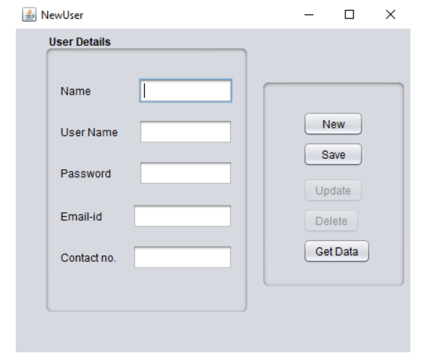
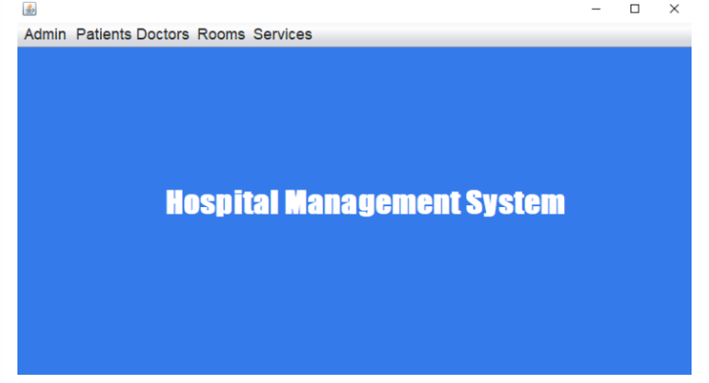
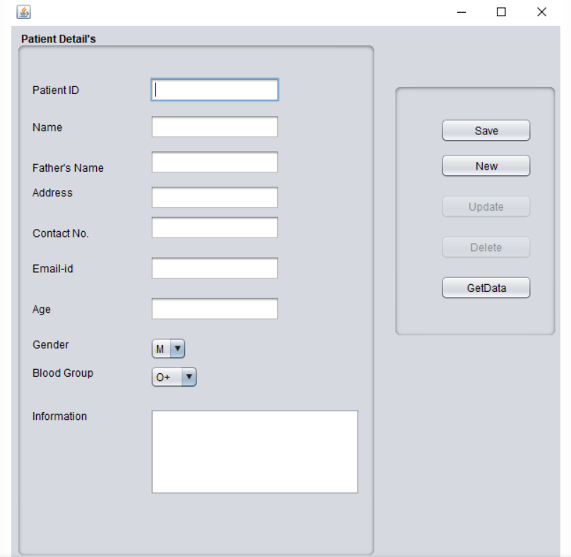

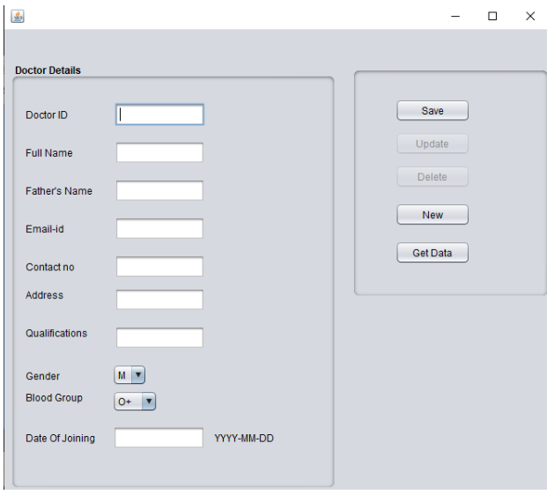
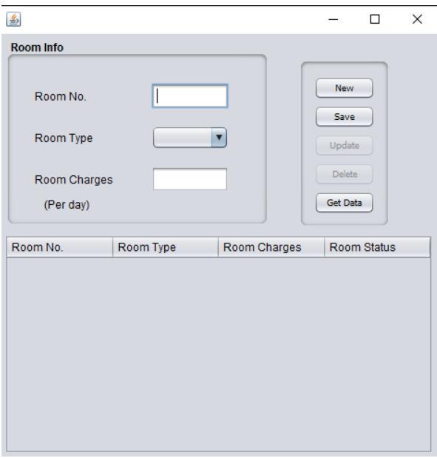

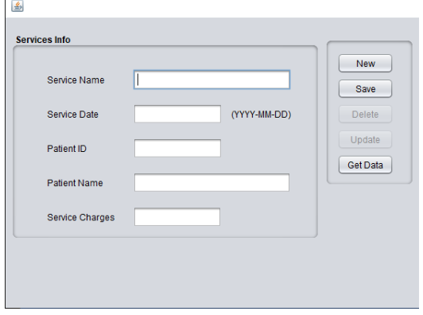

APPLICATIONS OF THE PROJECT

The Hospital Management System is designed to largely automate and streamline various operations within a hospital setup, including core functions like patient management, appointment scheduling, billing processing, and inventory management through a single digital platform. By deploying this comprehensive system, hospitals can greatly enhance their overall efficiency, greatly reduce the risk of human errors, and ultimately enhance the quality of healthcare services provided to patients.

1)Patient Record Management
Effectively stores, updates, and retrieves patient information like medical history, test results, and personal information, minimizing paperwork and loss of data.

2)Doctor Management
Begins to assign physicians to patients sequentiallythereby optimizing and streamlining coordination between patients and physicians.

3)Billing and Invoicing
Automatically creates bills based on medications, treatments, and consultations, along with patient and service history.

4)Staff and User Identity Authentication
Guarantees safe access by the use of specific user roles like administrator, doctor, and receptionist, and strong authentication processes. This is effective in protecting data privacy as well as restricting the level of access to the system.

5)Room Management
Allows us to allocate rooms to the patients and need for allocation and treatment becomes easier.

LIMITATIONS
- Limited User Roles: The current system is configured in a way that it supports only one admin role. Hence, there are no specific logins or special dashboards for other key personnel like doctors, nurses, or receptionists.

- Lack of Real-Time Updates: Without advanced synchronization mechanisms, any updates like information about the availability of rooms or the status of appointments might not be updated in real-time for all users.

- Basic Validation and Security: It is important to note that the system may not incorporate strong encryption methods or thorough validation procedures, which could potentially make it susceptible to unauthorized access by malicious actors or allow for data tampering, compromising the integrity of the information.

- No Cloud or Remote Access: The specific solution here is typically framed to be operating on a desk, and, therefore, users must access this from a pre-defined, definite point where this has been configured and installed.

- No Integrated Communications: Lacks facilities like SMS/mail reminders for appointments or patient recall, which are standard in today's HMS products.

- Manual Data Entry Dependence: Much of the data entry function, including inputting patient data or scheduling physicians, must be carried out manually by hand. This dependence on manual entry cannot fail but raise the specter of human error being introduced into the process.

- Lack of Advanced Analytics: The platform might not have predictive analytics features or recommendations based on artificial intelligence to optimize treatment or resource utilization.

BIBILIOGRAPHY

The development of this projectwas supported by a range of resources, including official documentation, tutorials, technical articles, academic papers, and reference books.Some of the references that were referred by me.

Healthray (2024). The Role of Modern Hospital Management Systems in Digital Healthcare (Role of Modern Hospital Management System in Digital Healthcare) (Role of Modern Hospital Management System in Digital Healthcare). (Discusses digital healthcare trends and HMS benefits.)
- Successive.Tech (2023). The Role of Hospital Management Systems in Streamlining Patient Care (How Hospital Management Systems Streamline Patient Care?). (Overview of HMS features and healthcare challenges.)
- Visual Paradigm. Hospital Management System – Use Case Diagram Template (Hospital Management System | Use Case Diagram Template) (Hospital Management System | Use Case Diagram Template). (Provides example HMS modules and use-case descriptions.)
- EHRinPractice (2024). The Problem with Paper Charting – and how EHR can help (The problem with paper charting - and how EHR can help). (Discusses inefficiencies of manual record-keeping in healthcare.)
- GeeksforGeeks. Java Database Connectivity with MySQL (Java Database Connectivity with MySQL | GeeksforGeeks). (Example of JDBC connection string usage.)
- EdrawMax (2023). Hospital Management System UML Diagrams. (Source of example UML activity diagram description (Activity Diagram for Hospital Management System | EdrawMax Templates).)

